PALURU PRAVALIKA
192371011
CSA0924-JAVA PROGRAMMING
SLOT D
1.Read an integer and determine whether it is divisible by 3, by 5, by both, or by neither.
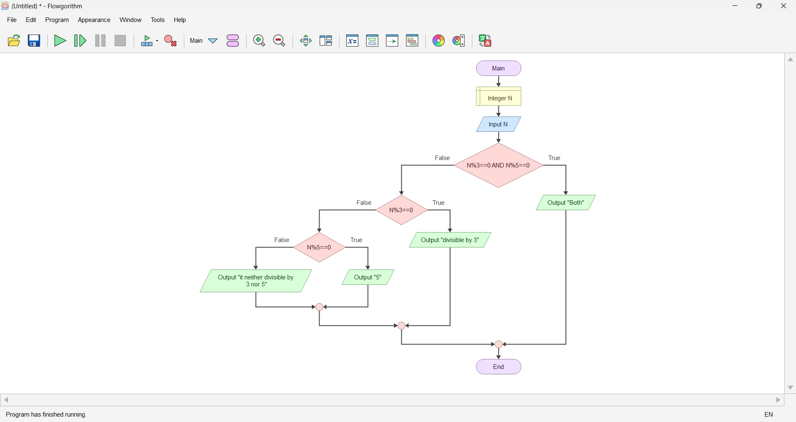
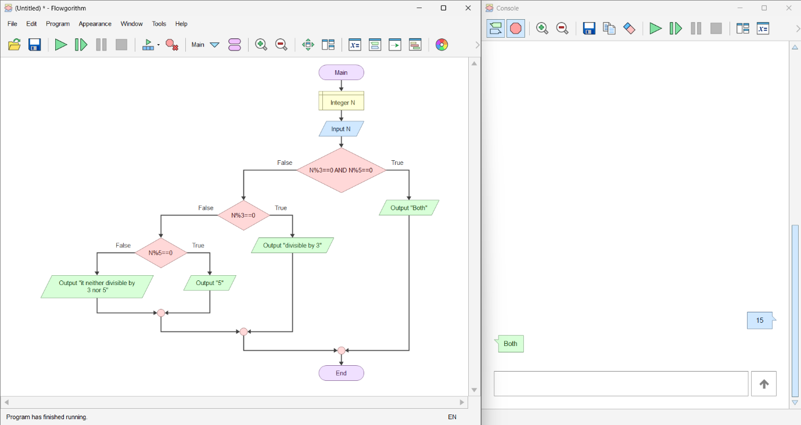
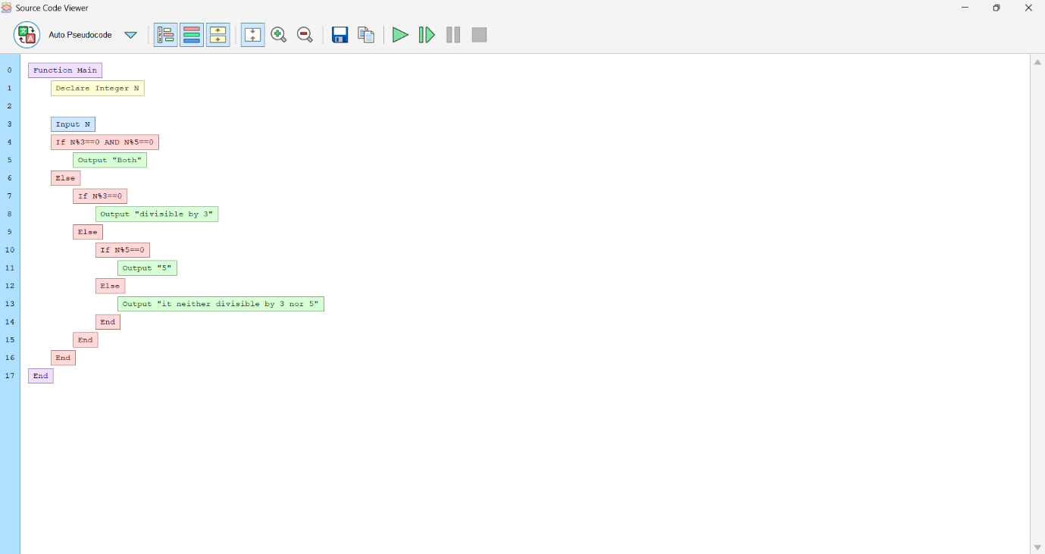
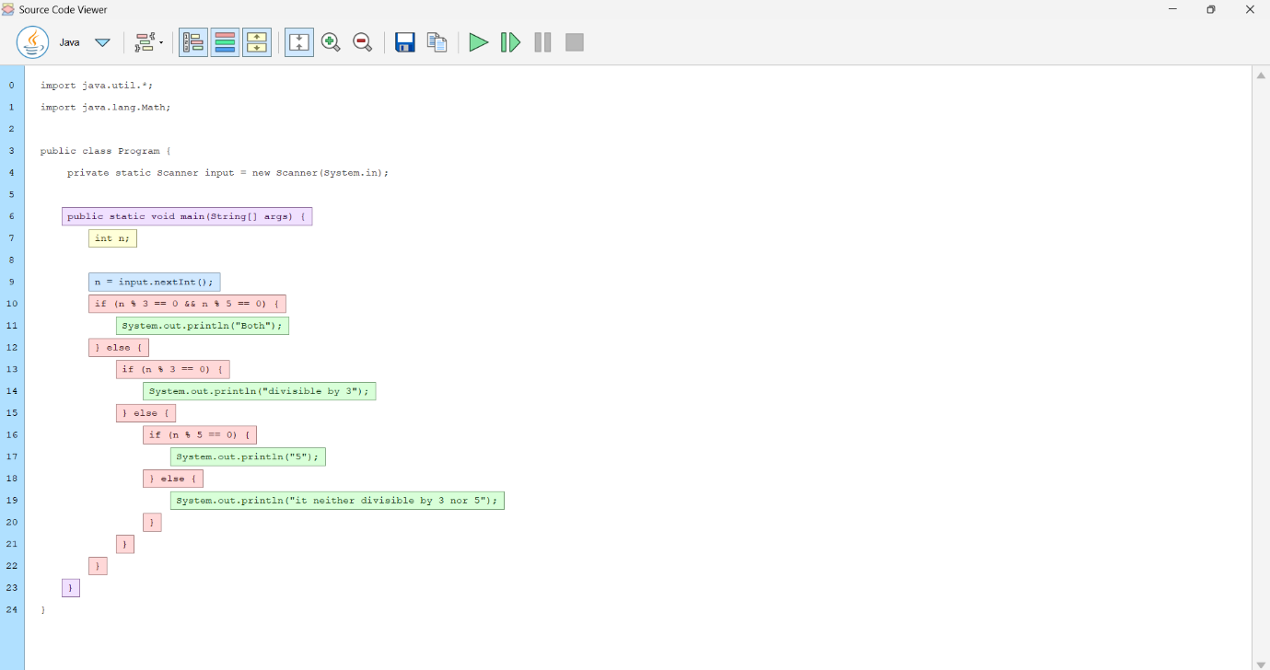
2. Read N item prices into an array, apply 10% discount to values above 1000, and display the revised prices and total.
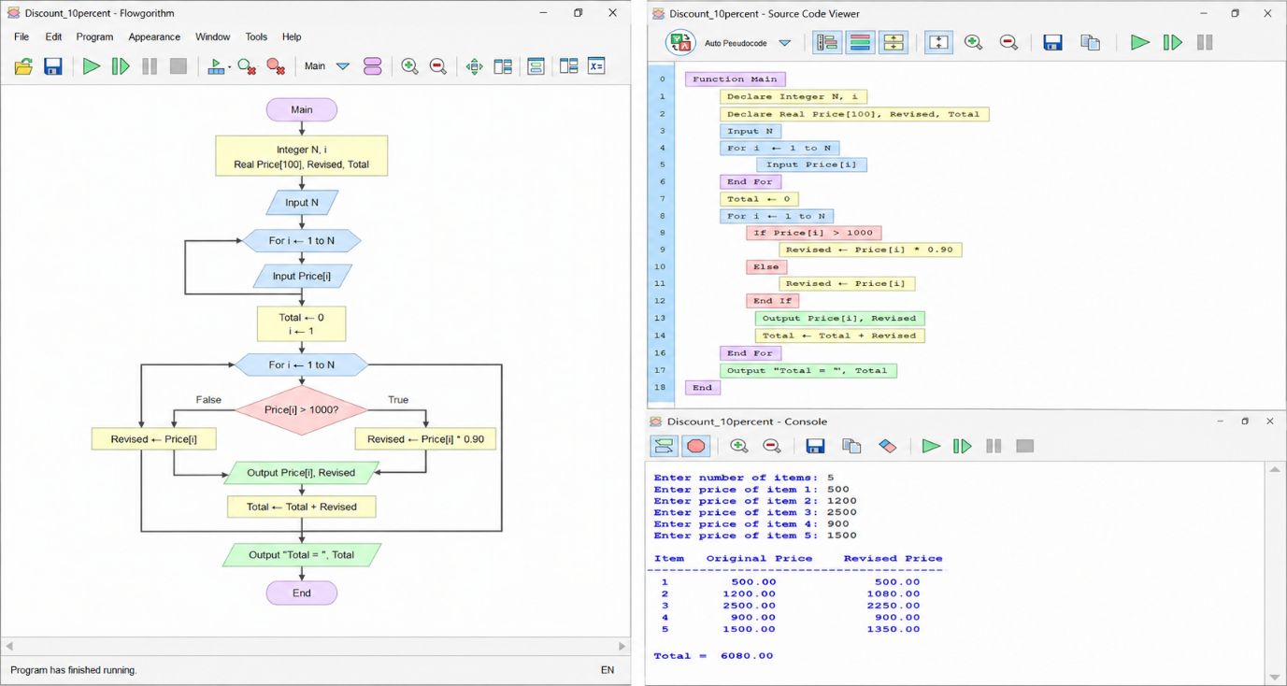

3. Create two conceptually overloaded average operations: one for two values and another for an
array. Implement them with distinct Flowgorithm function names and describe the Java version.
